*Heroes of Pymoli*

*Heroes of Pymoli* (HOP), the newest offering from *Pymol Games*, is small but growing. While the total revenue for the first month is below where the company had originally hoped, the purchase/player ratio is promising. Given more users, HOP may generate revenue to sustain other projects within the company. However, more data regarding the timing of purchases and duration between purchases (ie. at launch or over larger periods of time) is absolutely necessary to conclude with more certainty sustainability and purchase rates for the game. As such, all of these conclusions regarding profitability should be taken loosely.

* 576/1163 of our total players have made at least one purchase in our game,[1] resulting in $2,379.77 total revenue.[2] While the numbers are small in comparison to some of the larger games on Steam—some of which have hundreds of thousand of players over time—if HOP achieves even a modicum of that success, the game may become profitable. *Dota Underlords*, a recent Free-to-Play (F2P) release by Valve, cracked the Top-10 Played on Steam, with over 40,000 daily players. By comparison, Albion Online, a F2P by a small studio, is near the bottom of the Top-100 Played, with roughly 3,300-4,700 daily players.[3] While we should not expect the same success as Valve, seeing a player-base of even 3,000 *monthly* users would theoretically increase total revenue.
* Our sales numbers largely reflect our player-base. Roughly 84% of our players are male, which matches our sales figures for male players. Concurrently, 14% of our player-base is female, which also matches our sales figures to female players.[4] Yet, while the player-base is mostly male, female players actually spent more on average. Moreover, while the sample size/group information is too small and vague to draw a definitive conclusion, Non-Binary and players who chose not to disclose gender actually spent the most on average.[5] This may say more regarding the spending habits of each gender, but the results may prove useful when considering if/how to market in-game purchases to each player group. The 3rd highest spender, for example, identifies as female,[6] so it may prove useful to consider further market research for gender.

Similarly, our sales numbers for various age groups correspond with our understanding of the player-base at large. Age 20-24 remains the largest portion of our player-base.[7]

* Our Sales Team should definitely modify item stats and pricing over time. *Pursuit, Cudgel of Necromancy*, for example, was a popular purchase by our players, but generated far less revenue than other similarly-popular items, due to its lower price.[8] However, the exact reasoning for the popularity of certain items remains unclear. Our developers should carefully consider item changes or price increases, though, since “nerfing” items may alienate our player-base in the long term. More data regarding item specifications, popularity, availability, etc. is critical to the development to the sustainability of HOP.

In sum, sales numbers/demographics for HOP are promising for future revenue and sustainability. Developing a system for reviewing item prices/specifications may increase profitability for each item over time, given careful consideration. Critically, we need far more research into the nature and timing of purchases in order to construct a long-term plan for HOP.

Figures

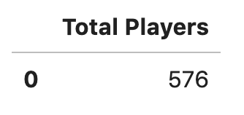

Figure : Total Player Count

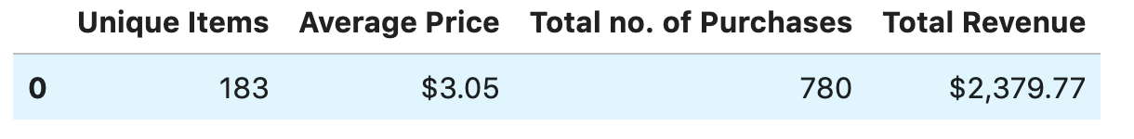

Figure : Total Item Sales

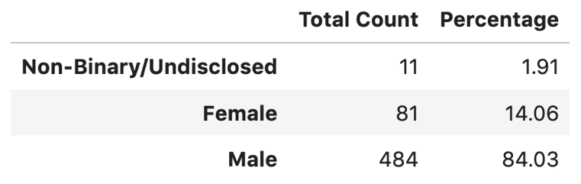

Figure : Gender Player Count

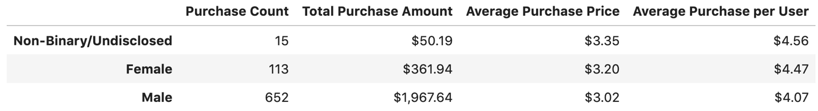

Figure : Gender Item Sales

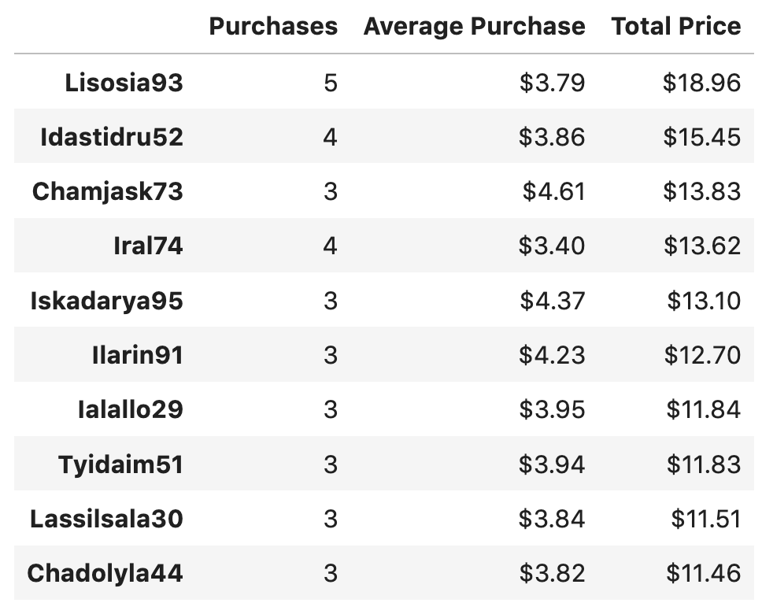

Figure 5: Top Spenders (Total Purchase Value)

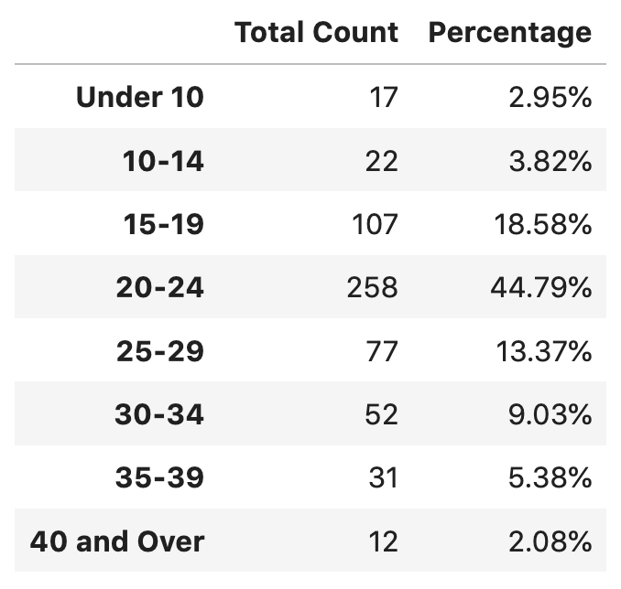

Figure 6: Age Groups

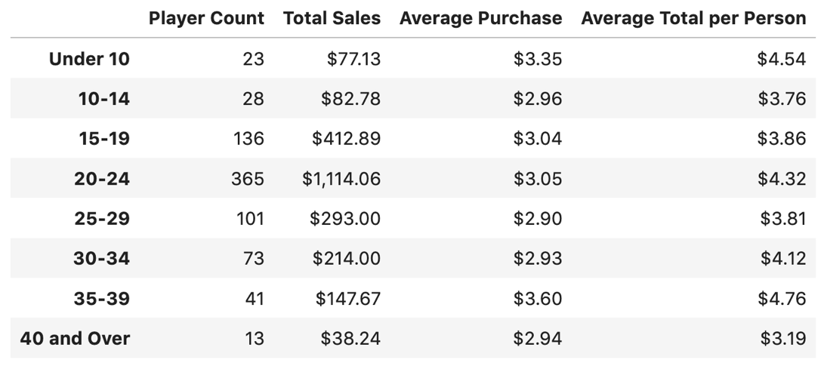

Figure 7: Age Group Sales

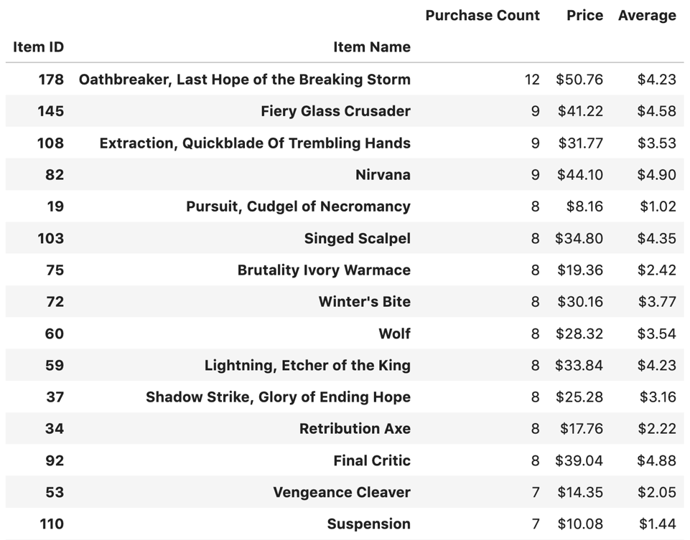

Figure 8: Top Items (Total Purchase Count)

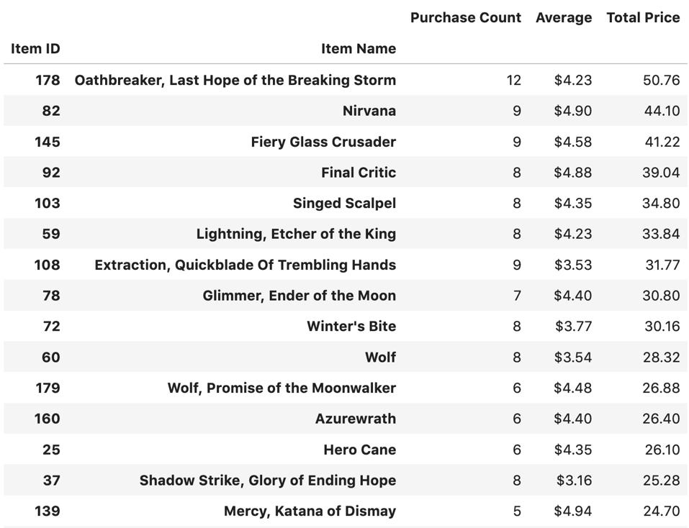

Figure 9: Top Items (Total Purchase Value)

1. See *Figure 1: Total Player Count*.
2. See *Figure 2: Total Item Sales*.
3. Numbers courtesy of <https://store.steampowered.com/stats/> (07/12/2019 c. 6:00p PST). Valve’s stats regarding players over time are notoriously vague, so please bear with me.
4. See *Figure 3*: *Gender Player Count.*
5. See *Figure 4: Gender Item Sales.*
6. See *Figure 5: Top Spenders (Total Purchase Value)*.
7. See *Figure 6: Age Groups* and *Figure 7: Age Group Sales.*
8. See *Figure 8: Top Items (Total Purchase Count)* and *Figure 9: Top Items (Total Purchase Value).*